APPLICATION FOR COMMUNITY INFRASTRUCTURE LEVY (CIL) GRANT
IN THE SUMMERTOWN & ST MARGARET’S [SuStM] NEIGHBOURHOOD FORUM AREA
2023

TITLE  Short title by which the project will be known | Improvements to Cherwell School pedestrian access.
PROJECT APPLICANT(S) & CONTACT DETAILS  Name of person (not organisation) who has initiated the project, with email & phone number | Mel de Freitas mel@meldefreitas.co.uk 07952 265001‬‬  Ben Willmore ben@willmore.eu 07986 377920
APPLICANT ORGANISATION  Name and type of organisation, if applicable, charity number. | Cherwell Travel Action Group (CTAG). We promote safe walking and cycling to and from Cherwell School.
STAKEHOLDERS & DETAILS OF CONSULTATION  (e.g. Council, Highways, site owner or asset holder, community organisation, business or neighbours) | Cherwell School (site user)
OUTLINE PROJECT DESCRIPTION  Short description so others not associated with the project can understand its purpose and scope. Include aims & objectives, and expected beneficiaries (max 150 words) | We propose to level and improve the verge on the Eastern side of the access road to Cherwell School South Site, off Marston Ferry Road. This road is used by hundreds of students at the Cherwell School every day to access the school site. The verge is supposed to be grassy, but due to heavy use, it is uneven and muddy. As a result, students have a choice between two bad options -- walking in the road or on the muddy verge.  We would level and stabilise the ground using a combination of hexagonal stabilisers and renewable materials (soil, sand and woodchip), to provide a good quality, mud-free walking surface. This would improve safety, encourage students to walk to school, and improve the appearance of the site entrance.
RELEVANCE TO THE NEIGHBOURHOOD PLAN  How does the project enhance or develop our neighbourhood? | The Cherwell School is a state secondary school in Summertown which is attended by around 2000 students, mostly from the immediate local area. Although the school is very successful, many parts of the grounds and surroundings are in disrepair due to funding pressures.  This proposal would benefit the local community in a number of ways:  - It would make access to Cherwell South Site safer for students, many of whom are local residents  - It would encourage walking to school, which would have beneficial effects on congestion and air pollution for the whole community, as well as health benefits for Cherwell students  - It would improve the appearance of a run-down area of the neighbourhood  - It would have mental health benefits for students who currently have to walk into school either along the road, or a muddy and litter-strewn grass verge.
CONSENTS REQUIRED  Are any legal consents required before the project can go ahead (e.g. from a Council department such as Highways, Planning, Building Control, or other statutory organisation)? | No
MAIN TASKS  A list of the main tasks and if appropriate an initial project plan with timescales. | - Remove the rotten fence at the north end of the verge  - Level the ground using topsoil  - Lay down hexagonal ground stabiliser and bed in with sand  - Cover with woodchips  We estimate that this work can be done by a handful of volunteers over the course of a day.
FINANCE  How much will this project cost in total? What proportion is being sought from CIL funding? What other sources of finance are being pursued? Are you seeking matched funding? What will the CIL grant be spent on?  PLEASE INCLUDE COPIES OF COST ESTIMATES | The total cost of the project will be £1301. We are seeking the whole amount from the CIL grant, but we will provide good value by recruiting volunteers to do the work.  Itemised costs:  The area is approximately 3m x 13m long, i.e. 39m².  Topsoil. 10cm average depth over the area = 3900 litres. Cost per 750 litre bag = £104.17. Total cost £520.85 inc VAT.  https://www.topsoilshop.co.uk/products/topsoil/Turfing-Topsoil-p173750307  Hexagonal stabiliser. To provide a 1.5m wide strip over the sloped area would require 7.5m². Price is £8.95 for 59cmx39cm. Total cost £291.72 inc VAT.  https://www.toolstation.com/plastic-ground-stabiliser/p89578  Sand. 5cm depth over the area of the hexagonal stabiliser = 0.98m³. 1 bulk bag = 0.5m³ and costs £79.20. Total cost £158.40.  https://www.travisperkins.co.uk/bagged-aggregates/travis-perkins-building-sand-bulk-bag/p/938155  Woodchips. 7.5cm depth over the area = 3000 litres. Cost per 2000 litre bag is £200, 100 litre bag is £130. Total cost £330 inc VAT.  https://www.barkukonline.co.uk/wood-chips/landscape-hardwood-chips

MAINTENANCE  How will the outputs of the project be maintained and by whom? Please note that CIL grants cannot be used to cover ongoing costs. | We do not envisage any significant maintenance costs -- the proposed materials should last for several years.
RISK ASSESSMENT  Are there any financial or other risks to the completion of this project?  Are there any safety issues associated with the project? | Financial risks: none  Safety issues: Minor risks to volunteers working on the site. We will provide appropriate hi-vis clothes and tools, cone off the site during work, and schedule work for a time when the road is not being used.
MONITORING AND REPORTING  How will the success of the project be monitored? | We will take photos of the site before and after the work has been done, to show the improvement. We will also count the number of pedestrians using the verge before and after the work is done.
OTHER COMMENTS OR INFORMATION  Please list anything else of relevance you wish the Committee to be aware of. Please submit a photograph of the site/equipment [as relevant]* | 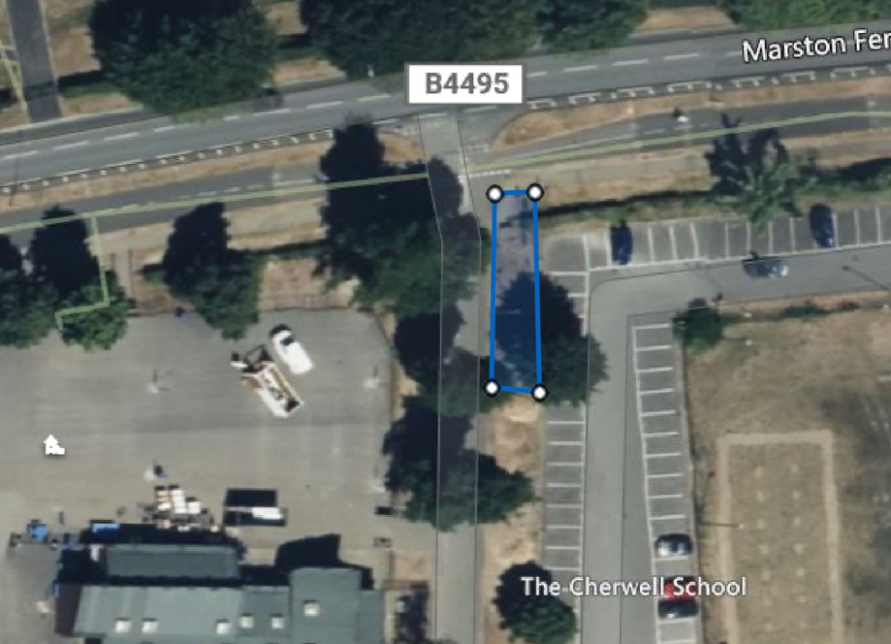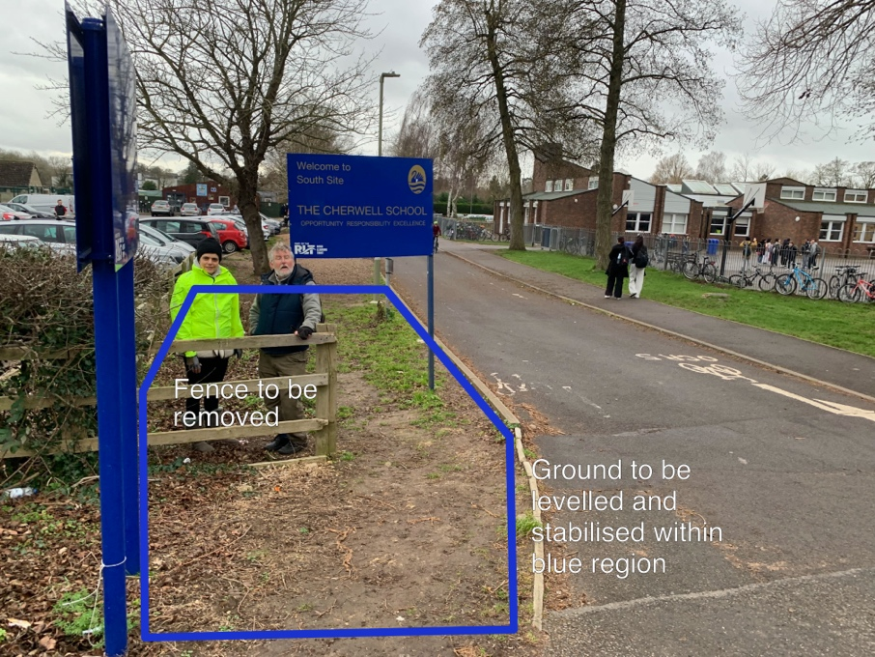
Completed applications, WITH COPIES OF COST ESTIMATES/QUOTES WHERE APPLICABLE, should be sent with a covering email to sstmnf.secretary@gmail.com

Further notes for applicants:
- The sections of the application form may be used flexibly to provide additional information where necessary. Not all sections will be relevant to all projects, and you may leave these blank.

- Applications will be assessed by the SuStM Steering Committee to include the following criteria and applicants may wish to include additional supporting information where relevant
- Location within or serving the SuStM Community
- The recipient operates as a recognised body with a nominated bank account
- The project has agreement in principle from the property or asset owner
- Value for money
- Impact of project
- Consideration has been given to health and safety requirements
- Environmental sustainability
- Innovation

* successful applicants will also be asked to supply photographs of completed work for the Forum’s annual report.

