Report on the SUSTM Transport Working Group’s (TWG)
Survey of Summertown’s Diamond Place Parking on
Wednesday 29 September & Saturday 9 October 2021
drafted by D.F. Bryceson
11 November 2021
TWG interviewers: Deborah Bryceson, Shamus Donald, Henk van Es,
Alison Hill, Katherine Miles, Natasha Robinson, David Nimmo Smith

The TWG undertook a small canvassing exercise conducted by its members, which involved short interviews with people paying for their parking tickets at the Pay & Display ticket dispenser at Diamond Place parking lot. The parking area has 122 car spaces. It is situated behind the Coop supermarket on the east side of the Banbury Road parade of shops with the site’s entrance on Banbury Road. It serves the parking needs of car drivers attracted to Summertown’s localized concentration of shops and services along both the Banbury Road and South Parade notably: four supermarkets, various specialized shops and a wide array of services for people seeking health care, dentistry, opticians, financial and legal services, mailing services, banking, estate agents, haircuts and beauty treatments, pharmacy, laundry services, etc. in addition to gyms, entertainment and a popular cluster of coffee shops, restaurants and a pub.

The TWG Survey interviews took place just to the side of the Pay & Display parking ticket machine for ease of identifying and interviewing parked car drivers (questionnaire attached, Appendix 1). Survey coverage was restricted to the main OCC parking area behind the Coop supermarket (not the Ewert House or Ferry Pool parking areas). The survey spanned 12 hours from 8 am to 8 pm, conducted on Wednesday 29th September and Saturday, 9th October, to compare differences in weekday and weekend parking .The parking lot operates on a 24 hour basis and is nearly empty late at night and early morning. Vans and cars of tradesmen and employees starting their workday begin arriving at 8 am and steadily increase after 9 am, often reaching near capacity by noon until late afternoon when the cars begin dwindling in number (photos in Appendix 2).

The interview objectives were to ascertain the locational origin of the cars and the driver’s purposes for parking at Diamond Place, as well as gathering views on the Diamond Place parking area.
It should be noted throughout this report that given our limited sampling time of only 2 days, our findings apply to those 2 days specifically. We would need far more diurnal data from additional days to begin to verify whether our findings were typical of weekdays and Saturdays. Regarding externalities that may have had an influence on the car parking volume and pattern: both days had rainless, unseasonably warm weather. On the 29th of September, there was a national petrol shortage that may have subdued the volume of traffic, but both days had very full parking at the peak time of 10:00 to 13:00.

Our information-gathering effort provides empirical base line data for future comparison with respect to:
- what impact the forthcoming opening of the 180-bed Easy Hotel will have on the parking pattern in Diamond Place, given the hotel does not provide hotel guest parking. We intend to repeat our survey interviewing next year after the hotel is in full operation.
- More generally our September/October data affords a base line for comparison for the decade to come, as new housing accommodation is built north of the Ring Road in close proximity to Summertown. This is anticipated to generate considerable additional traffic passing as well as customers for Summertown’s shops and services with the possibility of increased parking demand.
- On the other hand, the impact of road improvements now under discussion for improvement of Banbury Road’s pedestrian pathways and cycle lanes may decrease car parking. Our data could provide a baseline for monitoring those developments and other changes in traffic layout and parking provisions over the next decade and beyond.
- Finally discussions are underway for Oxford City Council as well as the University-owned areas of Diamond Place (DP) to be commercially developed. This base line study provides documentation of diurnal and seasonal difference in parking patterns which may be relevant for DP planning if and whena change in parking provision is considered in the future.

The TWG Survey took place by the Pay & Display parking ticket machine for ease of identifying and interviewing parked car drivers. Survey coverage was restricted to the main OCC parking area behind the Coop supermarket (not the Ewert House or Ferry Pool parking areas). The survey spanned 12 hours from 8 am to 8 pm, conducted on Wednesday 29th September and Saturday, 9th October, to compare differences in weekday and weekend parking. Regarding externalities that may have had an influence on the car parking volume and pattern: both days had fair, rainless, unseasonably warm weather. On the 29th of September, there was a national petrol shortage that may have subdued the volume of traffic, but both days had very full parking at the peak time of 10:00 to 13:00 (see photos).

On the days of the survey, all the interviewed parkers were using their cars rather than another mode of transport and were asked why they came by car. The following reasons were given:
1) coming from distant places: too far for walking or cycling or in the absence of a direct bus route, and
2) family travel – due to multiple family member numbers bus is too expensive or unwieldy for group cycling or walking,
3) heavy load carrying,
4) senior citizens with lowered predilection to other transport modes,
5) reluctance to travel by bus due to the threat of Covid, and
6) impaired mobility or health.

The catchment area for Diamond Place parkers encompassed driving distances as far as 254 miles on the weekday and 183 miles on the weekend. Average car distances travelled on each day were as follows:

Table 1
Average miles travelled between the car’s source and destination on survey days
 | Average travelled  car distance | Average distance minus cars travelling  >50 miles | No. of cars travelling >50 miles | % of total cars travelling >50 miles
Weekday, 29 Sept | 17.3 | 11.2 | 4 out 70 | 6%
Saturday, 9 Oct | 24.0 | 13.6 | 12 out of 94 | 13%
Source: SUSTM, Transport Working Group Survey, 2021

The higher incidence of long distance travel on Saturday coincided with more recreationally purposed traffic as well as parents bringing their student offspring from distant home areas to Oxford for the beginning of the University term.

Figure 1 Figure 2

Source: SUSTM, Transport Working Group Survey, 2021

Travel purpose shifted significantly between the weekday and the weekend, which affected travel distance from point of origin. Table 3 shows the contrasting distances.

Table 2
Distance travelled by Diamond Place Parked Vehicles’ from Point of Origin (% of total parkers)
Day of week | < 5 miles | - miles | >15 miles
Wednesday | 33% | 44% | 23%
Saturday | 50% | 21% | 29%
Source: SUSTM, Transport Working Group Survey, 2021

The catchment area for those stating that their purpose at Diamond Place was shopping was mostly local within a 5 mile radius but extended as far as 23 miles. Summertown shopping centre attracts primarily local clientele but a rise in long-distance drivers at Diamond Place occurred during the weekend mostly on the part of people coming to Summertown to eat out and to meet friends and family. Interestingly, Saturdays represented polarization of travel distance between those who were the local population (50% greater than during the week) and others coming from more distant place (26% greater). Parkers from medium range distances of 5-15 miles were less prevalent, possibly because they mainly comprised a business/working population servicing Summertown, who preferred to spend their weekends more home-based.
Figure 3
Weekday - Car Parkers’ Distance of Travel & Purpose
(% of total purposes)
Distance (miles) |  | 1 |  | 2 | 3 | 4 | 5 | 6 | 7 | 8 | 9
0-2 |  | 9.5 |  | 0.0 | 1.4 | 2.7 | 0.0 | 0.0 | 0.0 | 0.0 | 1.4
.2-5 |  | 5.4 |  | 6.8 | 1.4 | 0.0 | 4.1 | 1.4 | 0.0 | 0.0 | 0.0
.5-10 |  | 6.8 |  | 1.4 | 0.0 | 1.4 | 5.4 | 2.7 | 1.4 | 6.8 | 0.0
.10-15 |  | 5.4 |  | 5.4 | 0.0 | 0.0 | 4.1 | 0.0 | 1.4 | 0.0 | 0.0
.15-40 |  | 2.7 |  | 1.4 | 4.1 | 0.0 | 4.1 | 0.0 | 0.0 | 1.4 | 0.0
.40-100 |  | 0.0 |  | 1.4 | 1.4 | 0.0 | 2.7 | 0.0 | 0.0 | 1.4 | 0.0
100-255 |  | 0.0 |  | 0.0 | 1.4 | 0.0 | 0.0 | 0.0 | 0.0 | 0.0 | 0.0
Unknown |  | 0.0 |  | 1.4 | 0.0 | 1.4 | 0.0 | 0.0 | 0.0 | 0.0 | 0.0
%purpose |  | 29.7 |  | 17.6 | 9.5 | 5.4 | 20.3 | 4.1 | 2.7 | 9.5 | 1.4
 | Purposive activity code for Figures 3 & 4:
 | 1-Shopping – supermarkets, speciality shops, charity shops
2-Services – professional personal services – hair salons, legal, financial,
medical, dentistry, physiotherapists, estate agents, counselling, etc
 | 3-Restaurants, pub, coffee shops, cooked food takeaway
 | 4-Gyms
 | 5-Business/Work
 | 6-School activities, delivery & pick-up of students from school
 | 7-Social meetings with friends/family
 | 8-Ewert House (Oxford University adult education centre)
 | 9-Car battery charging
10-Entertainment – live music events, The North Wall theatre, etc
11-Public toilet

Figure 4
Weekend - Car Parkers’ Distance of Travel & Purpose
(% of total purposes)

Source: SUSTM, Transport Working Group Survey, 2021

While shopping was singly the most salient purpose for parking on both days, a comparison of Figures 3 & 4 reveals that evidentially the combination of professional people offering: services (2), work/business activities (5) & Ewert House (8) educational course attenders amounted to 47.4% of total purposes on the weekday as opposed to weekday shoppers (1) representing only 29.7% of the sample, suggesting that Summertown functions primarily as a business and educational centre during the week. As business and service activities eclipse at the weekend, Summertown comes into its own as a destination for recreation and leisure activity with restaurants (3), gyms (4), meeting friends/family (7) and entertainment (10) totalling 35.1%, as opposed to only 17.6% during the weekends. Thus, leisure activities doubled on Saturdays compared to the weekend.

A 1998 survey of Summertown, examining shopping patterns drew attention to the ‘significant decline in the number of people doing their main shopping at Summertown from perhaps 60% to 40% and those of the sample doing their main shopping in out-of-town superstores expanding from nil to 40%’ with the introduction of the Kidlington superstore having the biggest impact on these percentages. It also noted that car use had declined by 10% and walking had increased by over 10% (Lingwood 1998: 95). However, the 1998 survey was focussed on shoppers and did not consider the role of professional services’ and recreational activities’ influence on modal traffic patterns. Recreational activities would generally affect a larger catchment, likely to attract considerable numbers of people travelling by car from distant places, as suggested by the Saturday purposive car parking data.

The diurnal pattern of purposive activity in our survey showed pronounced weekday and weekend contrasts. On the weekdays Summertown activity started early with tradesmen and business people arriving when the parking lot was almost empty. Due to the acute shortage of residential parking in Summertown, some builders and repair people could not get parking near the place where they were working and had to park for the duration of their work and in the case of many builders for the whole day in Diamond Place parking lot.

Table 5
Wednesday Diamond Place Parking by Purpose & Hour
 |  | Purposes
Time |  | 1 |  | 2 |  | 3 | 4 | 5 | 6 | 7 | 8 | 9 | Total Purposes
8am |  | 0 |  | 1 |  | 0 | 0 | 6 | 1 | 1 | 0 | 0 | 9 | 1-Shopping
9am |  | 1 |  | 2 |  | 1 | 0 | 2 | 2 | 0 | 3 | 0 | 11 | 2-Services
10am |  | 5 |  | 0 |  | 0 | 0 | 1 | 0 | 0 | 2 | 0 | 8 | 3-Restaurants
11am |  | 6 |  | 2 |  | 0 | 0 | 0 | 0 | 1 | 0 | 0 | 9 | 4-Gym
12am |  | 3 |  | 2 |  | 2 | 2 | 2 | 0 | 0 | 0 | 0 | 11 | 5-Business/Work
14pm |  | 2 |  | 1 |  | 0 | 0 | 1 | 0 | 0 | 0 | 0 | 4 | 6-School pick-up/activity
15pm |  | 0 |  | 2 |  | 0 | 0 | 1 | 0 | 0 | 0 | 1 | 4 | 7-Meeting friends/family
16pm |  | 2 |  | 1 |  | 0 | 1 | 1 | 0 | 0 | 0 | 0 | 5 | 8-Ewert House
17pm |  | 1 |  | 2 |  | 0 | 0 | 0 | 0 | 0 | 0 | 0 | 3 | 9-Car battery charging
18pm |  | 2 |  | 0 |  | 4 | 1 | 0 | 0 | 0 | 0 | 0 | 7
19pm |  | 0 |  | 0 |  | 0 | 0 | 1 | 0 | 0 | 2 | 0 | 3
% of total purposes |  | 29.7 |  | 17.6 |  | 9.5 | 5.4 | 20.3 | 4.1 | 2.7 | 9.5 | 1.4 | 74

Figure 6
Saturday Diamond Place Parking by Purpose & Hour
Purposes
Time | 1 | 2 | 3 | 4 | 5 | 6 | 7 | 8 | 9 | 10 | 11 | Total  Purposes
8am | 3 | 2 | 0 | 1 | 0 | 1 | 0 | 0 | 0 | 0 | 0 | 7
9am | 6 | 1 | 2 | 1 | 0 | 2 | 0 | 0 | 0 | 3 | 0 | 15 | 1-Shopping
10am | 9 | 1 | 2 | 0 | 1 | 3 | 2 | 0 | 0 | 0 | 0 | 18 | 2-Services
11am | 2 | 0 | 2 | 0 | 2 | 2 | 0 | 0 | 0 | 1 | 0 | 9 | 3-Restaurants
12am | 5 | 1 | 0 | 0 | 2 | 0 | 1 | 0 | 1 | 0 | 1 | 11 | 4-Gym
13pm | 7 | 0 | 4 | 0 | 0 | 0 | 0 | 0 | 0 | 1 | 0 | 12 | 5-Business
14pm | 3 | 2 | 2 | 0 | 0 | 0 | 1 | 0 | 0 | 0 | 0 | 8 | 6-School Pick-up/Activities
15pm | 2 | 0 | 1 | 0 | 0 | 1 | 1 | 0 | 0 | 0 | 0 | 5 | 7-Meeting friends/families
16pm | 2 | 0 | 4 | 0 | 1 | 1 | 1 | 0 | 0 | 0 | 0 | 9 | 8-Ewert House
17pm | 5 | 0 | 4 | 0 | 0 | 0 | 2 | 0 | 0 | 1 | 0 | 12 | 9-Car Battery Charging
18pm | 3 | 0 | 2 | 0 | 0 | 0 | 0 | 0 | 0 | 0 | 0 | 5 | 10-Entertainment
% of total purposes | 42.3 | 6.3 | 21 | 1.8 | 5.4 | 9.0 | 7.2 | 0 | 0.9 | 5.4 | 0.9 | 111 | 11-Toilet
Source: SUSTM, Transport Working Group Survey, 2021

Tables 5 and 6 indicate that shopping was primarily a mid-morning to early afternoon activity. People came for scheduled services stretched out across the working day from 8-17 hours during the weekday and negligible at the weekend. Restaurant visits were spread throughout the day on weekdays, but had a clear dinner time delineation on Saturday. Most other activities were sprinkled throughout the day without a specific pattern.

It is worth noting that gender differentiation by purposive activity was very conventional on weekdays with men dominating parking for business and work purposes while women were twice as likely as men to be shopping. Interestingly, on Saturday the reverse happened with men displacing women shoppers at more than double the number, as well as making a strong showing at cafes and restaurants (Figures 7 and 8).
Figure 7 Figure 8

Source: SUSTM, Transport Working Group Survey, 2021

Age-differentiated patterns are not analysed here, but will be considered in any TWG follow-up comparative survey. Suffice to say that the average age of respondents was 51 years old on weekdays as well as during weekends, indicative of a more aged population than what prevails in most other parts of Oxford. The age range was 25-82 during the weekday survey and 17 to 87 years of age at the weekend.

This survey focussed entirely on those who were using the Diamond Place parking lot on the survey days. Our interviewees were asked ‘what modes of transport do you rely on to come to Summertown shopping area in order of frequency?’ This revealed that 83% normally drove to Summertown, but 9% cycled, 4% walked and 4% took the bus as their most frequent option, indicating that 16% of the parkers were flexible about their transport mode usage. Summertown car reliance reflects our survey design not the overall travel patterns of Summertown. We were sampling car drivers at the Pay & Display who had an average age of 50+. It must be borne in mind that the survey did not include non-parkers, and was not aimed at discerning the patterns of those using walking or cycling modes of transport on the survey days. The responses below are representative of people who are likely to have a predilection for car driving given their age, impaired mobility, distant point of origin, or travelling as a family.

Table 3
Modes of Transport most used by the Car Parking Respondents to Travel to Summertown Shopping Area
(% of total responses)

Motorized
Car/Van Bicycle Walking Bus
Weekday | 83.8 | 8.8 | 1.5 | 5.9
Weekend | 83.0 | 9.6 | 6.4 | 1.1
Mean | 83.4 | 9.2 | 3.9 | 3.5
Source: SuStm, Transport Working Group Survey, 2021

In conclusion, this report provides a record of our baseline survey findings. The survey is planned to be repeated again next year to ascertain the impact of the Easy Hotel residents on parking in Diamond Place and will hopefully be useful for comparison with future parking patterns if housing development expands north of the ring road as planned.

Please send any comments and criticisms of the survey findings to: dfbryceson@bryceson.net.

Appendix 1:
SuStm Neighbourhood Canvassing Questions re. Diamond Place Parking

Interview Date: Time:

What is your full postcode?
e.g. OX2 6 or OX15 7 (record without last 2 letters)
Why are you parking here today? (List multiple reasons with Xs)
1-Shopping
2-Services
3-Restaurant
4-Gym
5-Business
6-School pick-up
7-Other - specify
How long do you plan to park here today? (Hours + Minutes)

Do you ever park in any alternative parking locations in ST
(List where in order of frequency – ‘1’ being most frequent)
1)
2)
3)
4)
What range of modes of transport do you rely on to come to ST shopping area?
List in order of frequency- most frequent = 1
(after completing list, asterisk the most preferred mode )
1)
2)
3)
4)
Explain why that mode is preferred?

Interviewee: M / F (Age)

Do you have any views about parking vis-à-vis current discussion about Diamond Place future development? Briefly note

Appendix 2: Photos of Diamond Place Parking Area on Survey Days, 2021

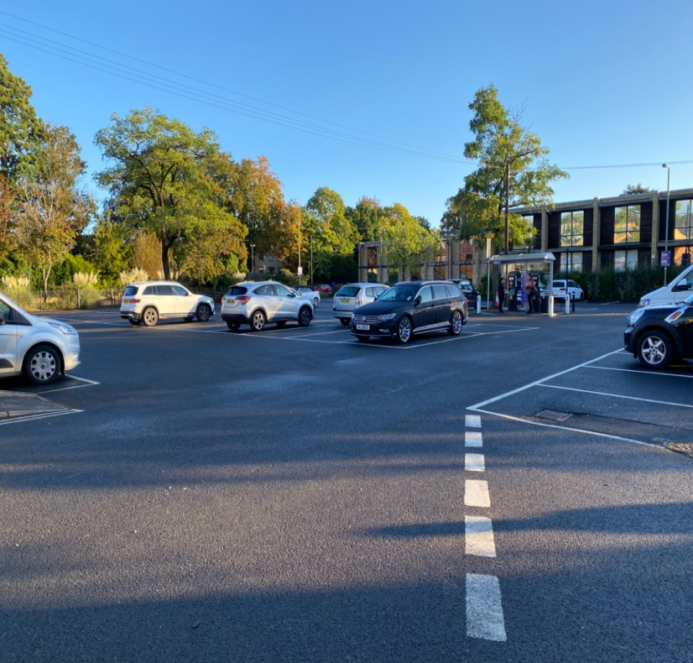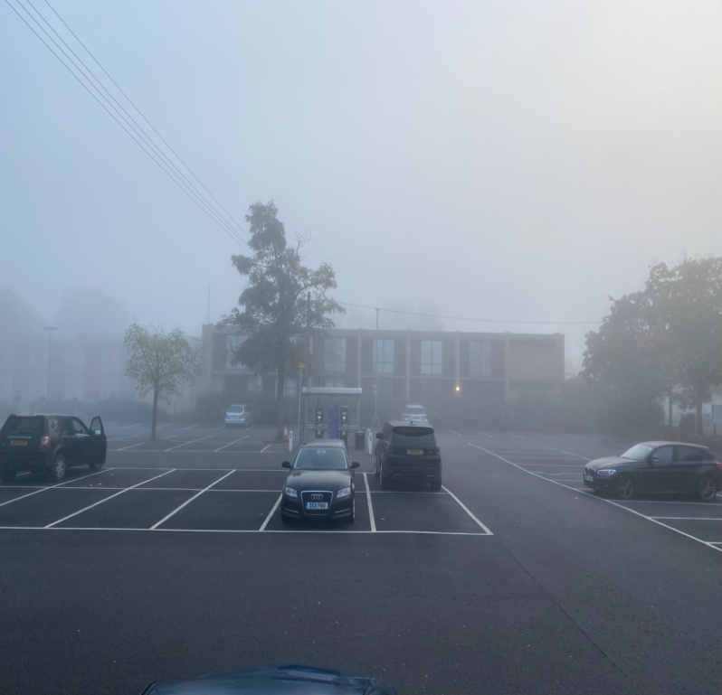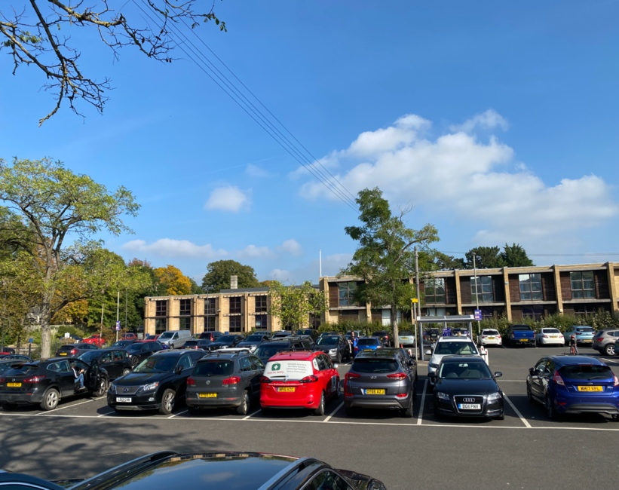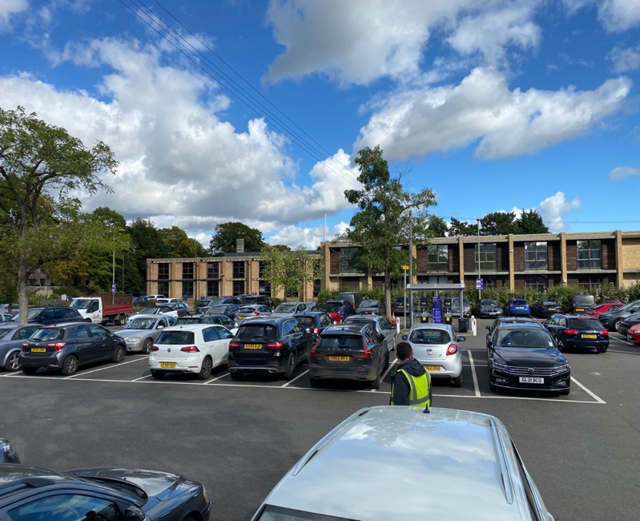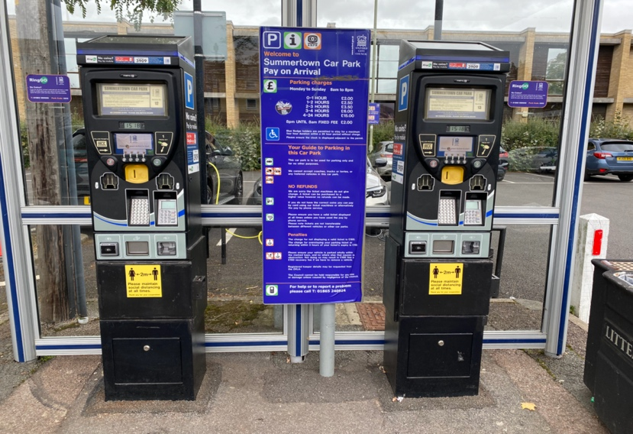
Sat 9 Oct 1:30 pm
Weds 29 Sept 2 pm
Sat 9 Oct 8 am
Weds 29 Sept 8 am
DIAMOND PLACE PARKING SURVEY 2021 20PARKING, 202 PARKINGPAPA

Parking tickets are charged at: 1 hour = £2.00, 1-2 hours = £2.5, 2-3 hours = £3.50, 4-24 hour = £15, after 8pm + £2.00. On average people parked the average duration of car parking of 2.7 hours on the weekday (valued at £3.50) and just 2.0 hours (£2.50) on Saturdays. For a family, it is likely that car parking for periods under 4 hours would be cheaper than the cost of family of two adults and two children coming by bus.
It should be noted that some parkers were using Ringo, a digital form of parking payment, that precludes them using the Pay and Display machines. We are seeking data from Oxford City Council about the diurnal pattern and volume of traffic which will hopefully shed light on what percentage of parkers use Ringo. More generally, knowing the quantitative total parking volume will complement our trip distance data and qualitative data on parking purpose.
See Lingwood, P. (1998) ‘Walking to the Shops’, MSC Transport Planning dissertation, Oxford Brookes University. I am grateful to Neil MacLennan for drawing my attention to this survey.
Age was usually asked by the interviewer but in some cases the interviewer estimated the age.

